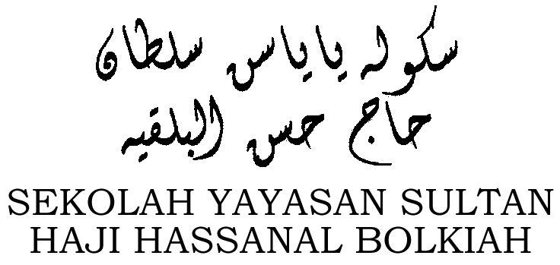

Sekolah Menengah Yayasan Sultan Haji Hassanal Bolkiah
FORM AVAILABLE
- Yayasan website
- Payment counter
- School Admin
CASH PAYMENT
- Cash payment only at the counter
ONLINE BANK TRANSFER
- BIBD only
Show receipt to claim school uniform from the school administration.
Screenshot and whatsapp to 8333000; then claim school uniform from the school administration.

OR

NOTE:
ONLINE BANK TRANSFER
- Reference 1 – Full name of the student
- Reference 2 – Class
- Reference 3 – School uniform payment

